**Nguyen Nam Khanh – HE191159 – IA1902 – IAM302**

**LAB 11: Using FOG for Cloning and Imaging Disks**

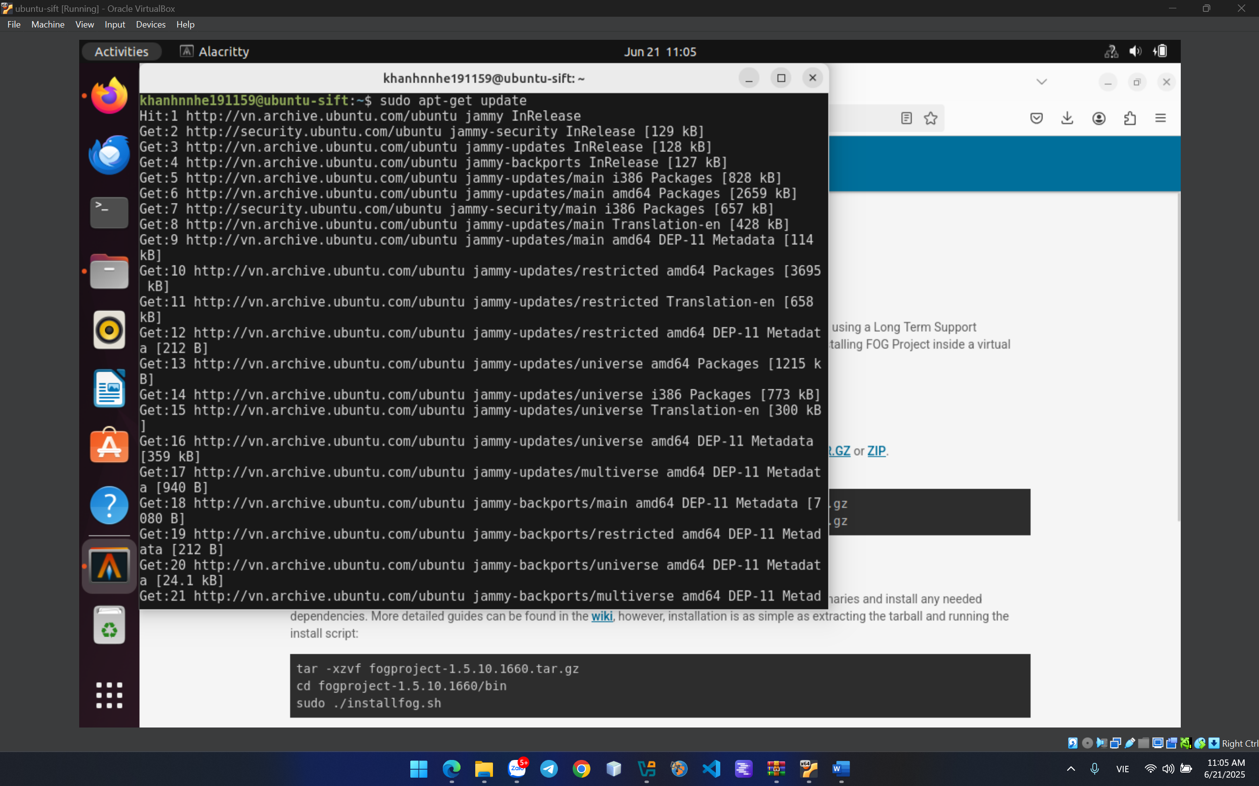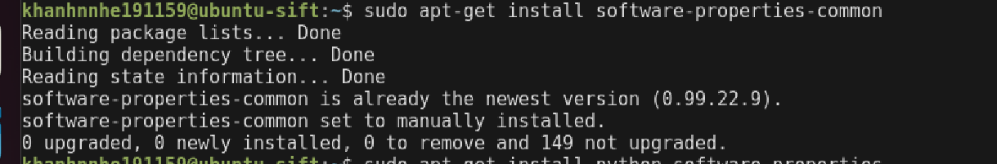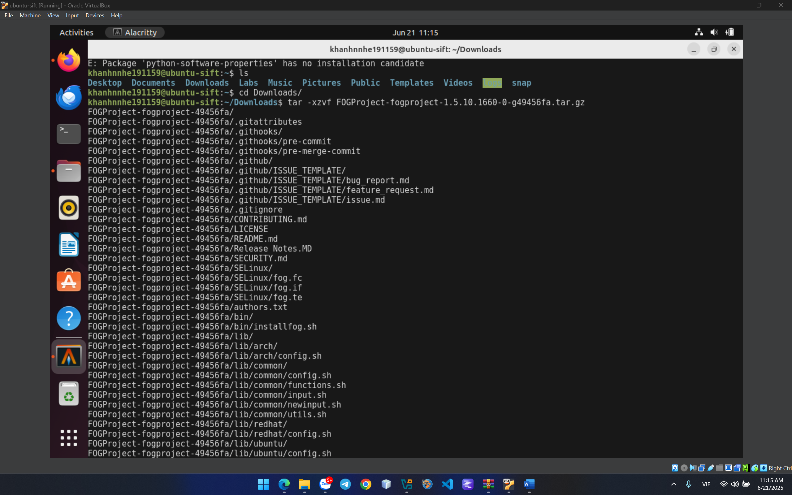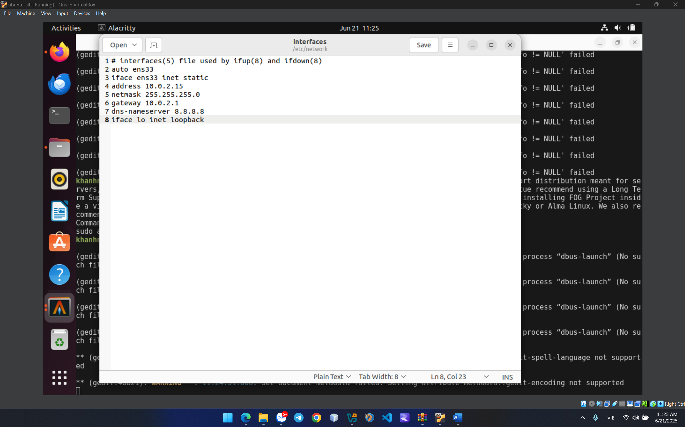

After reboot

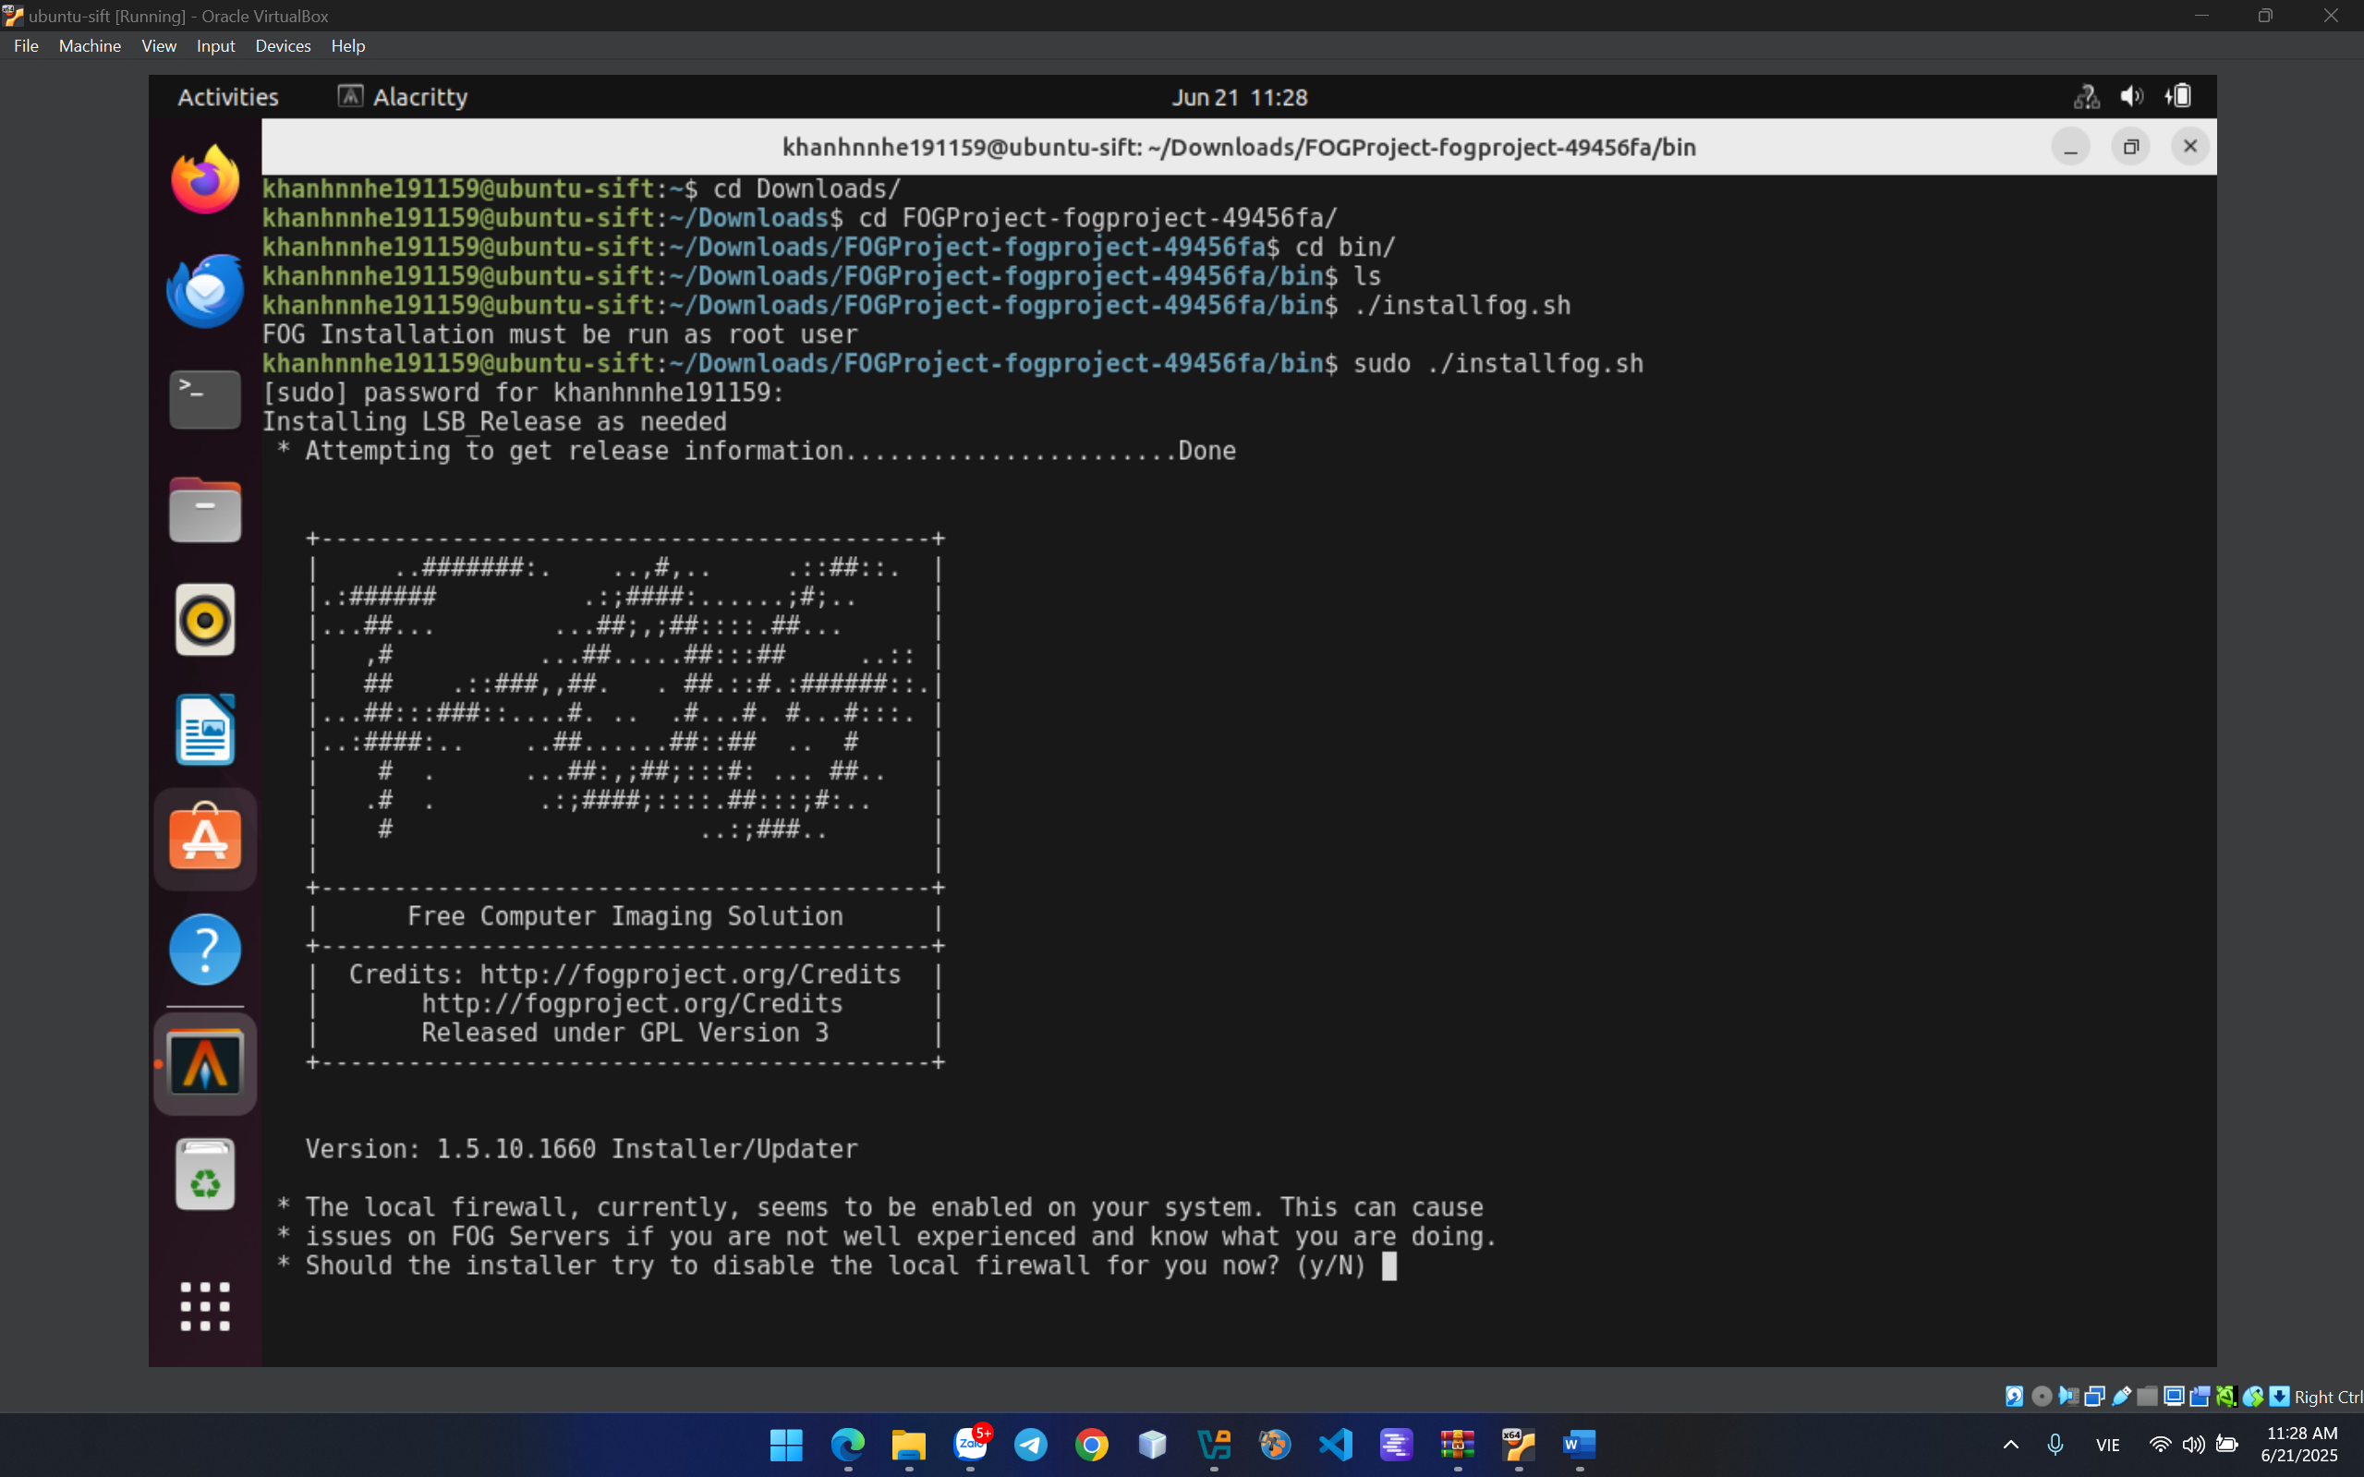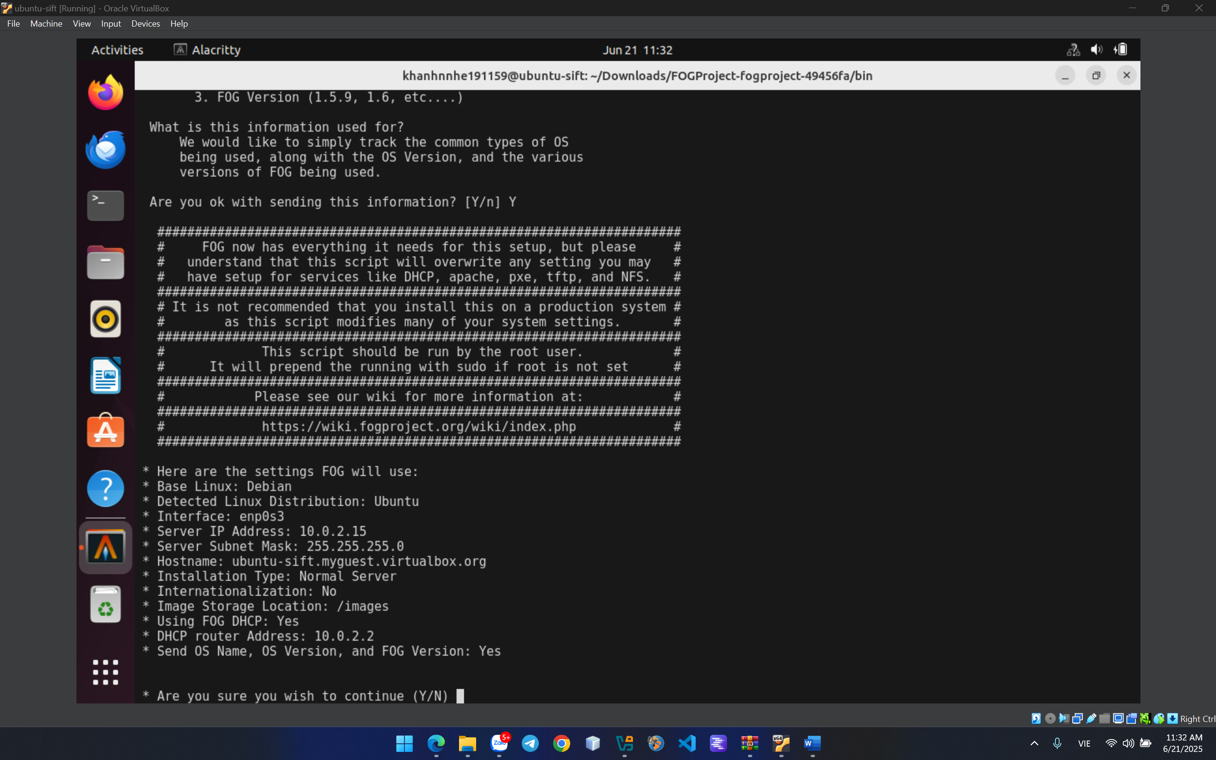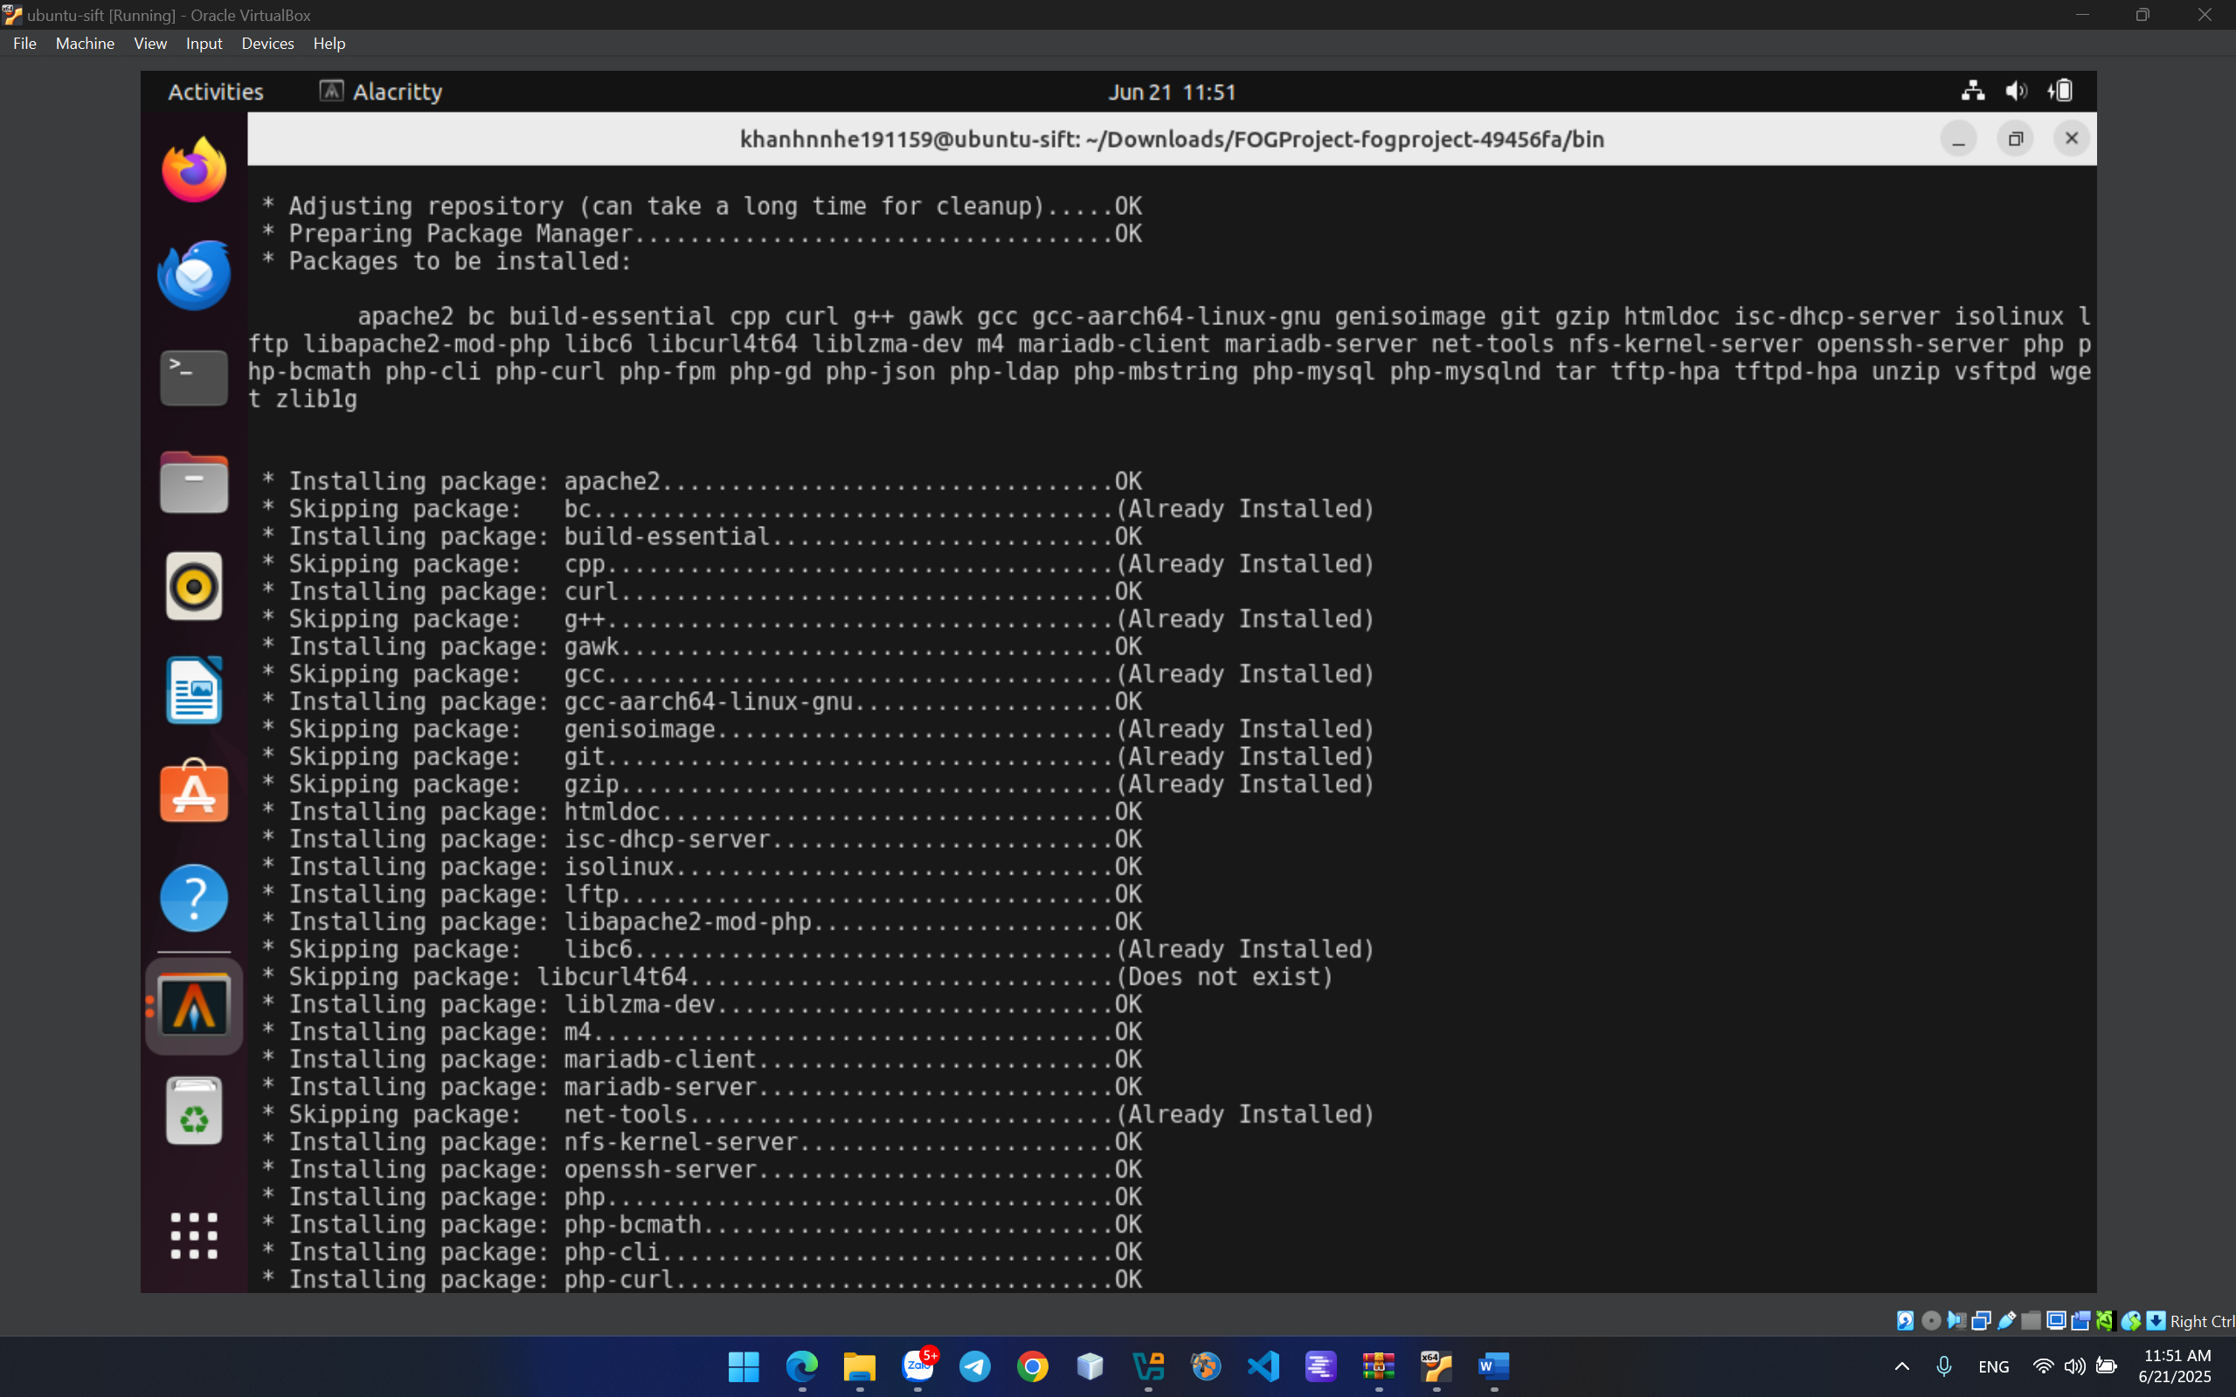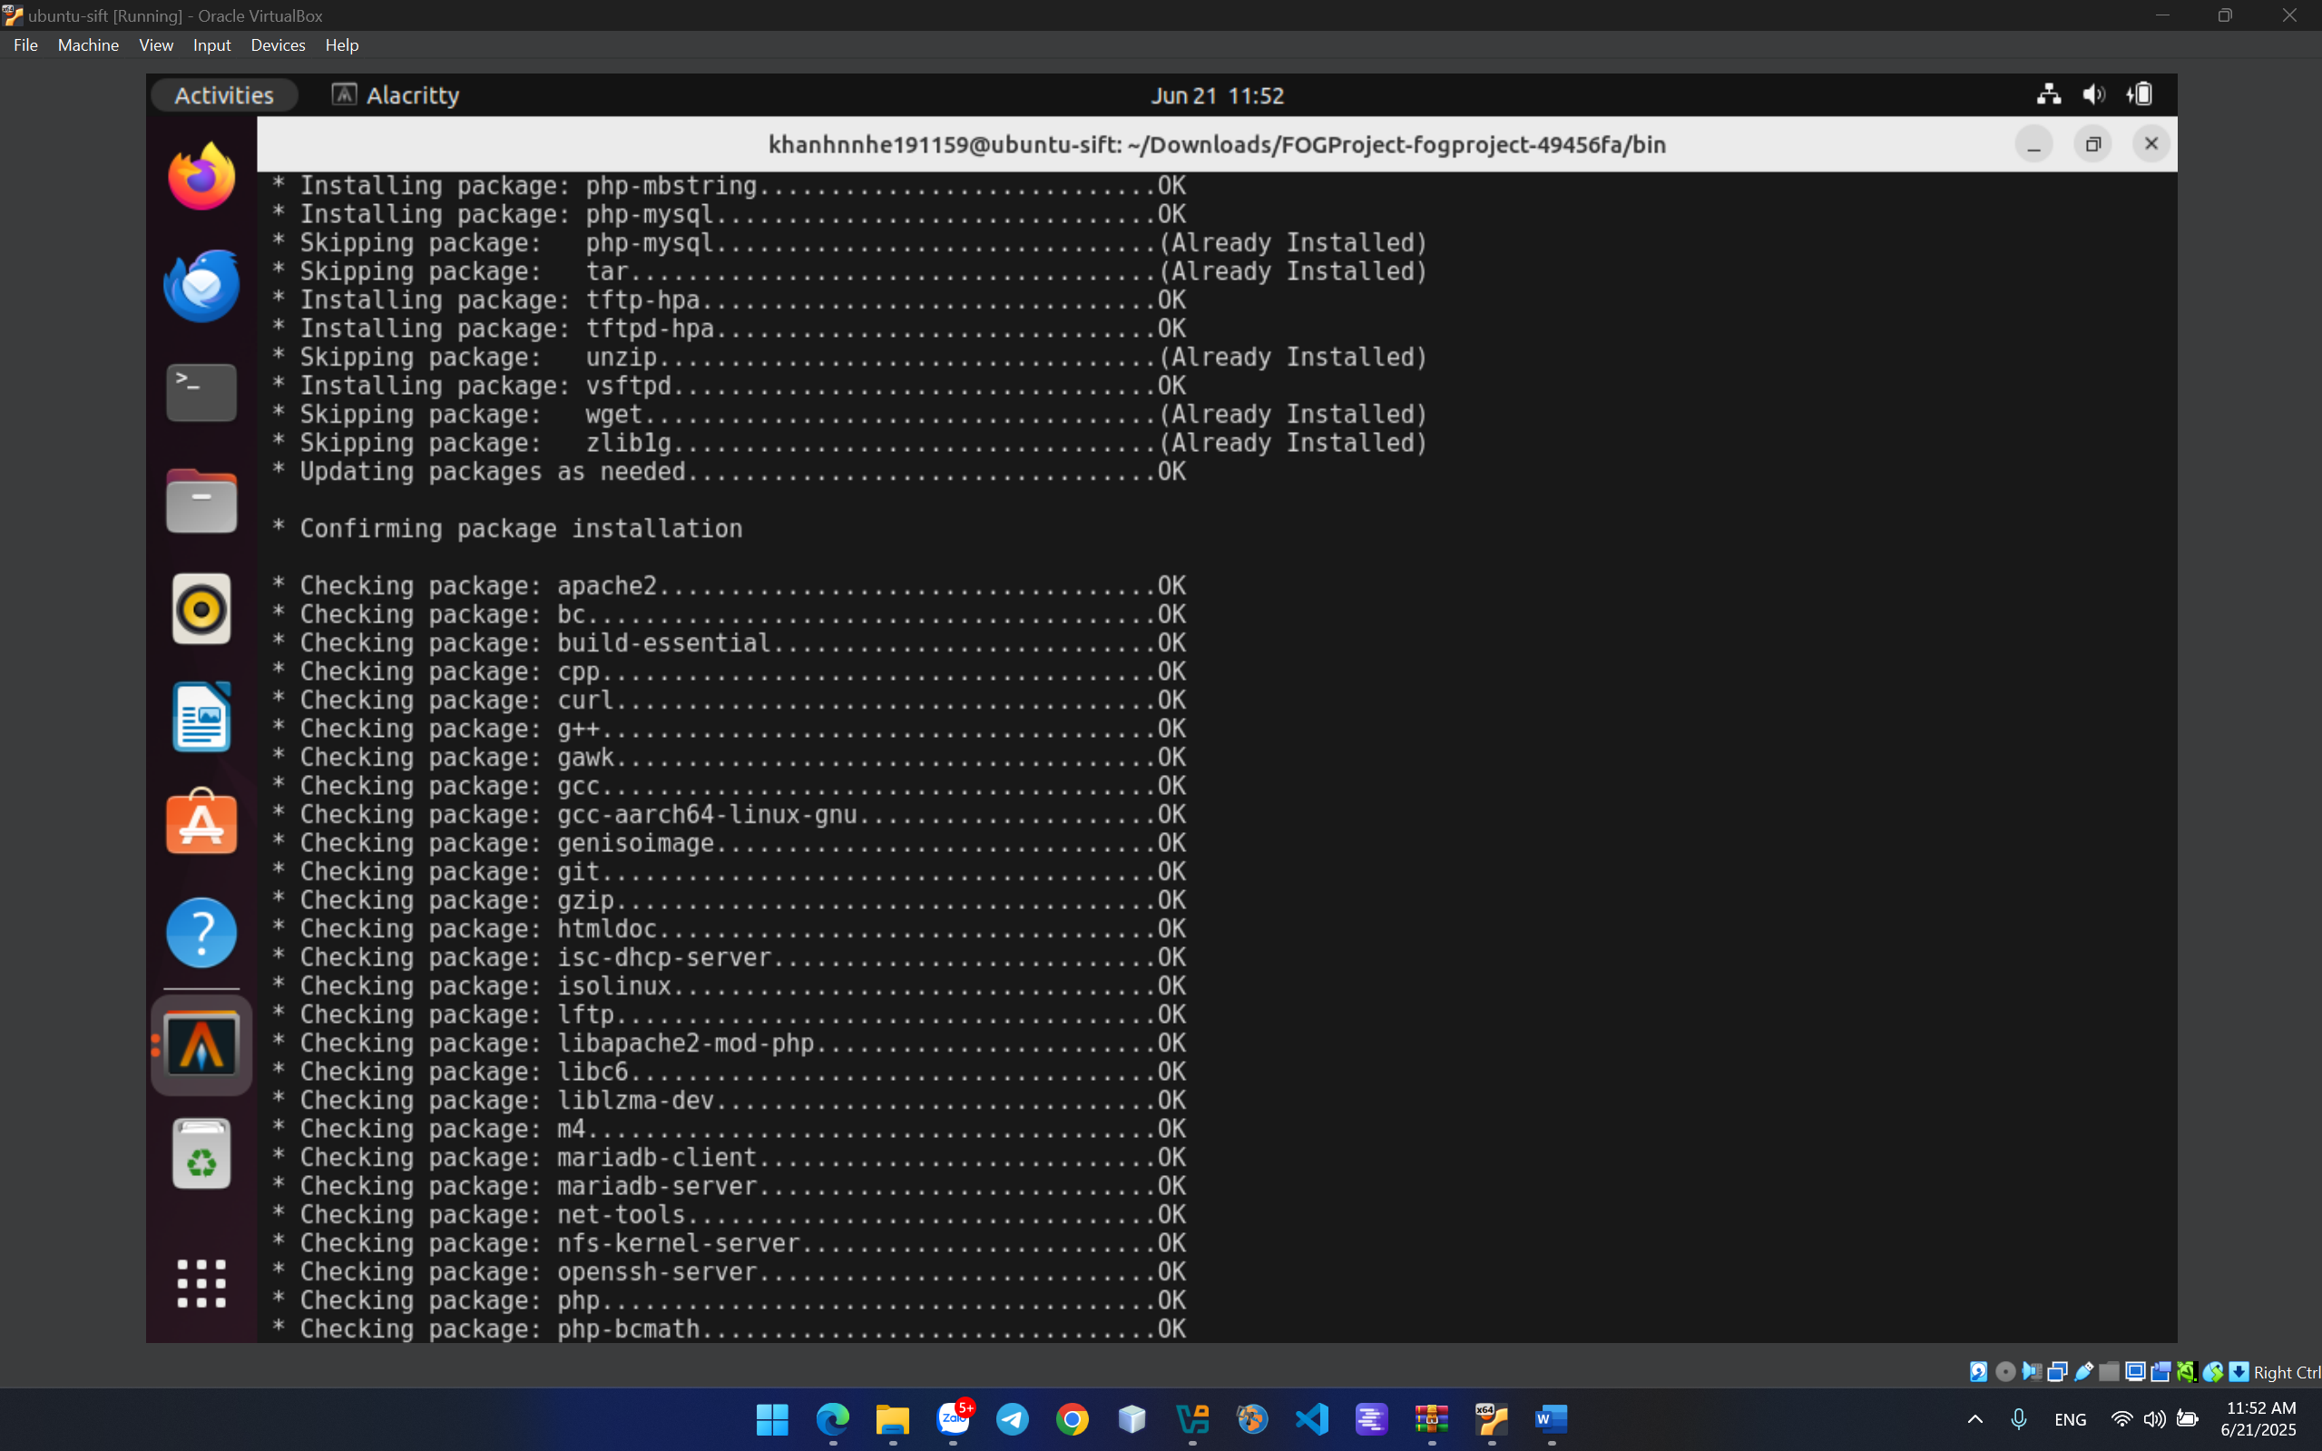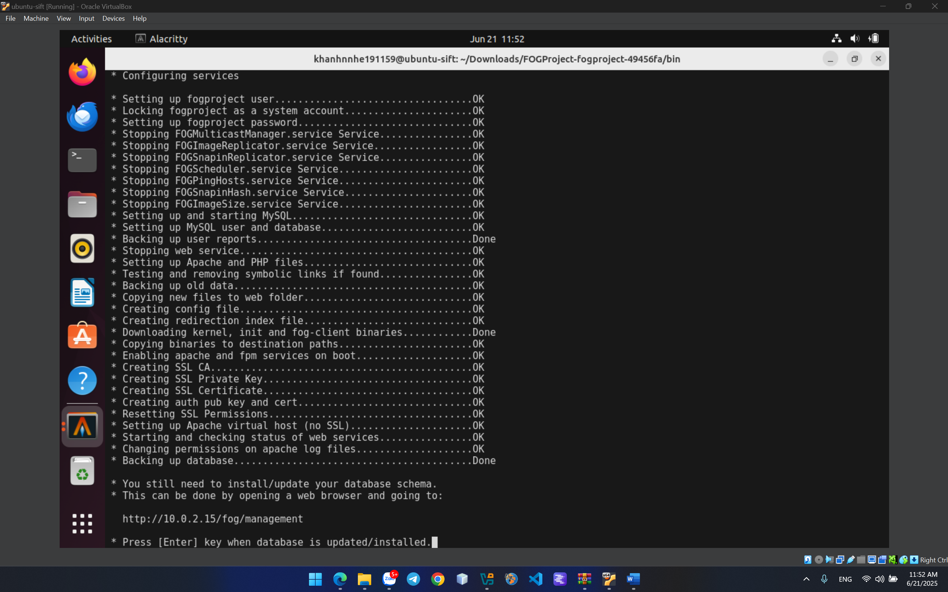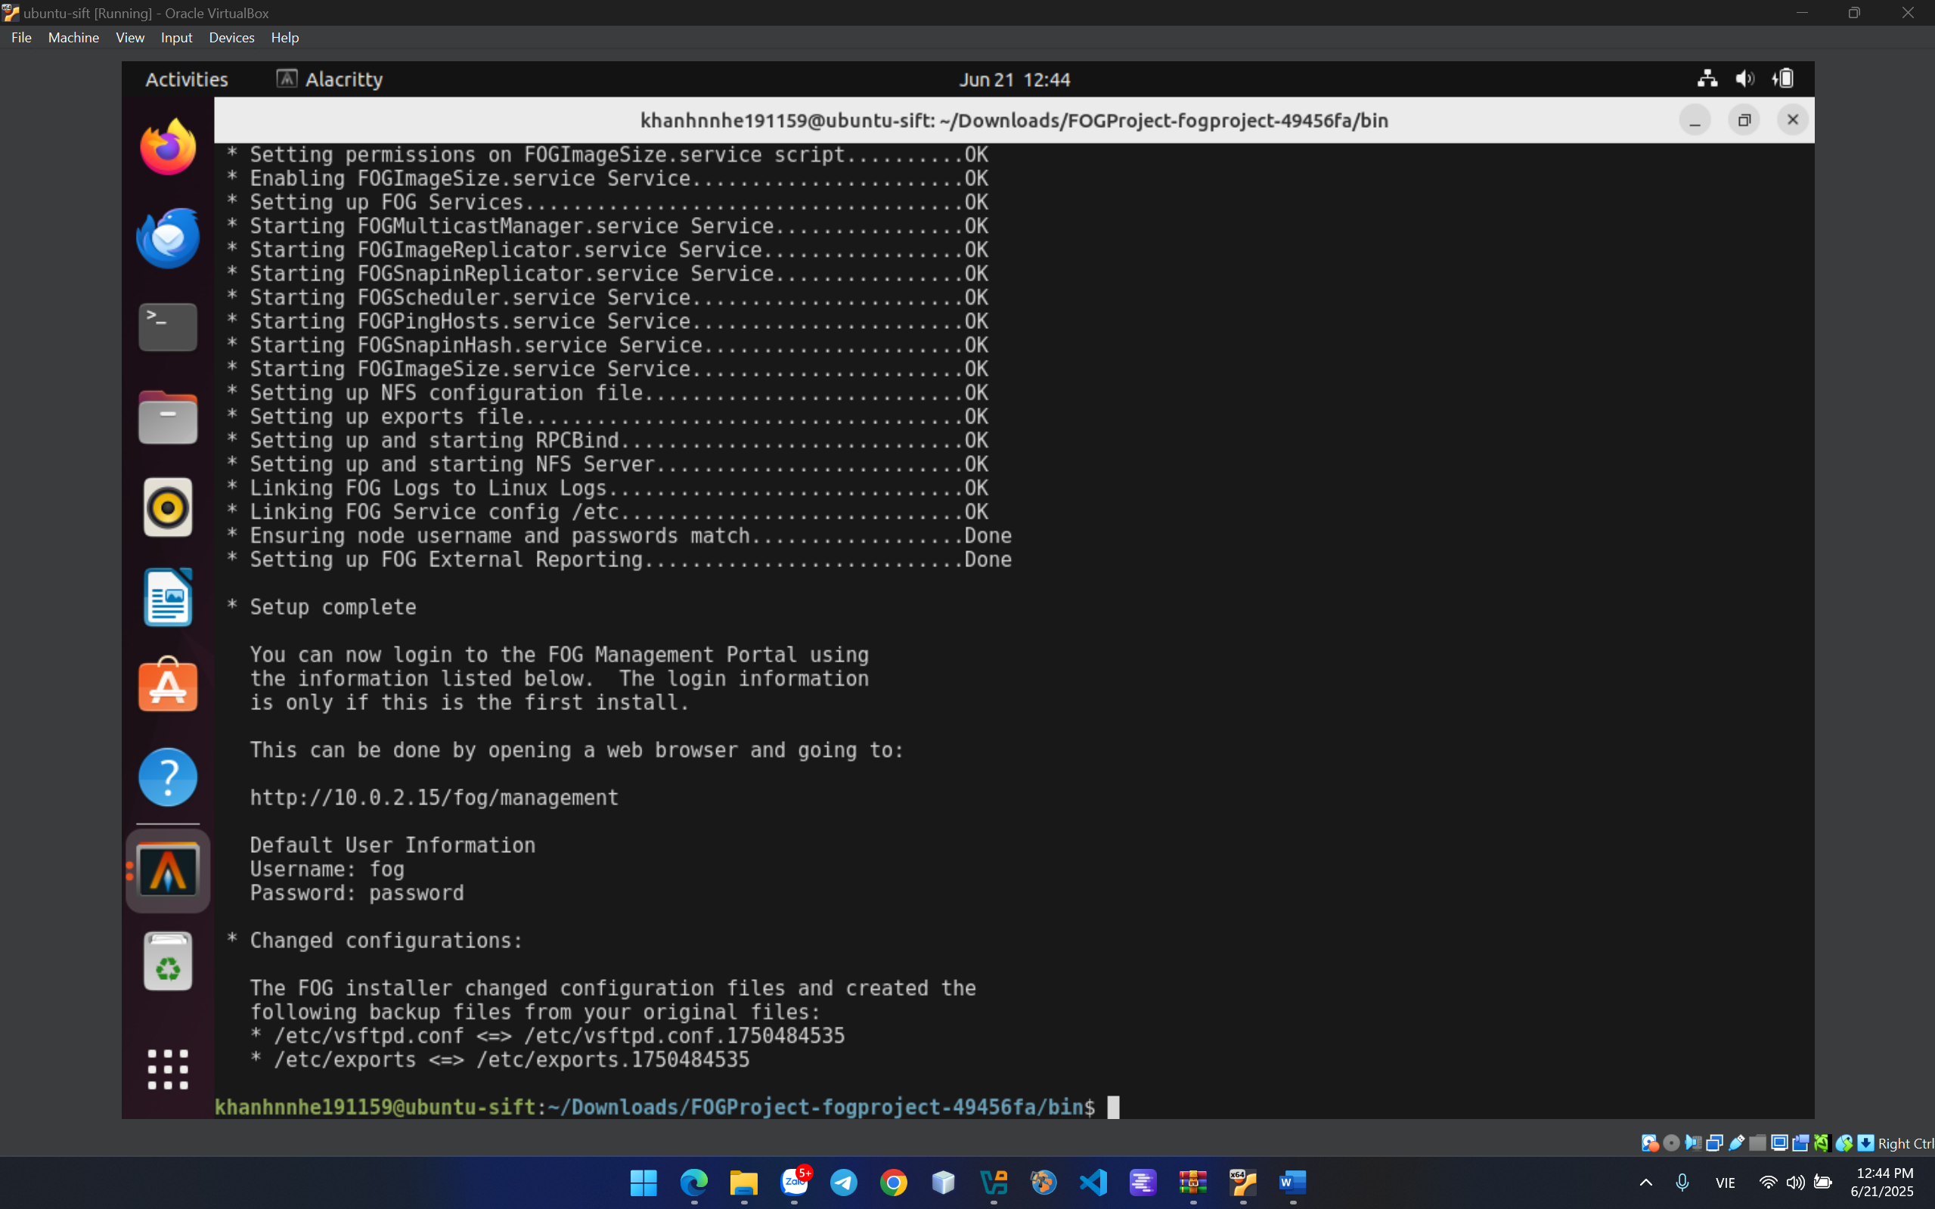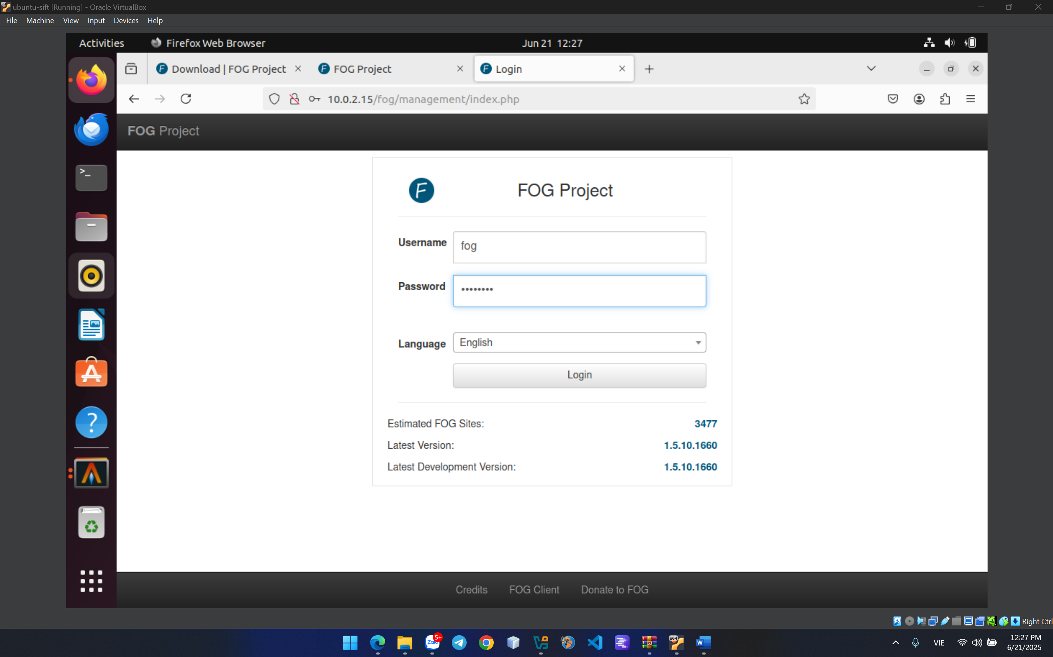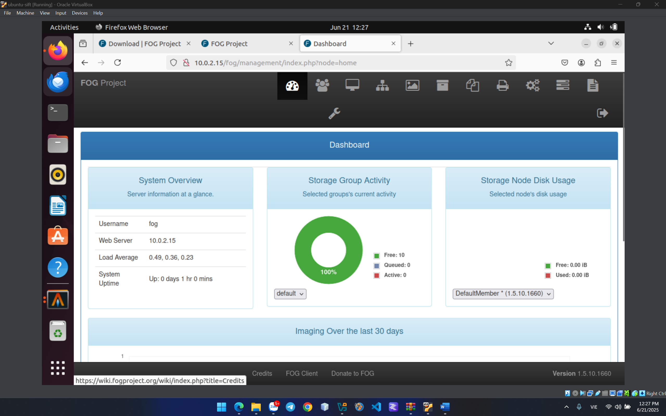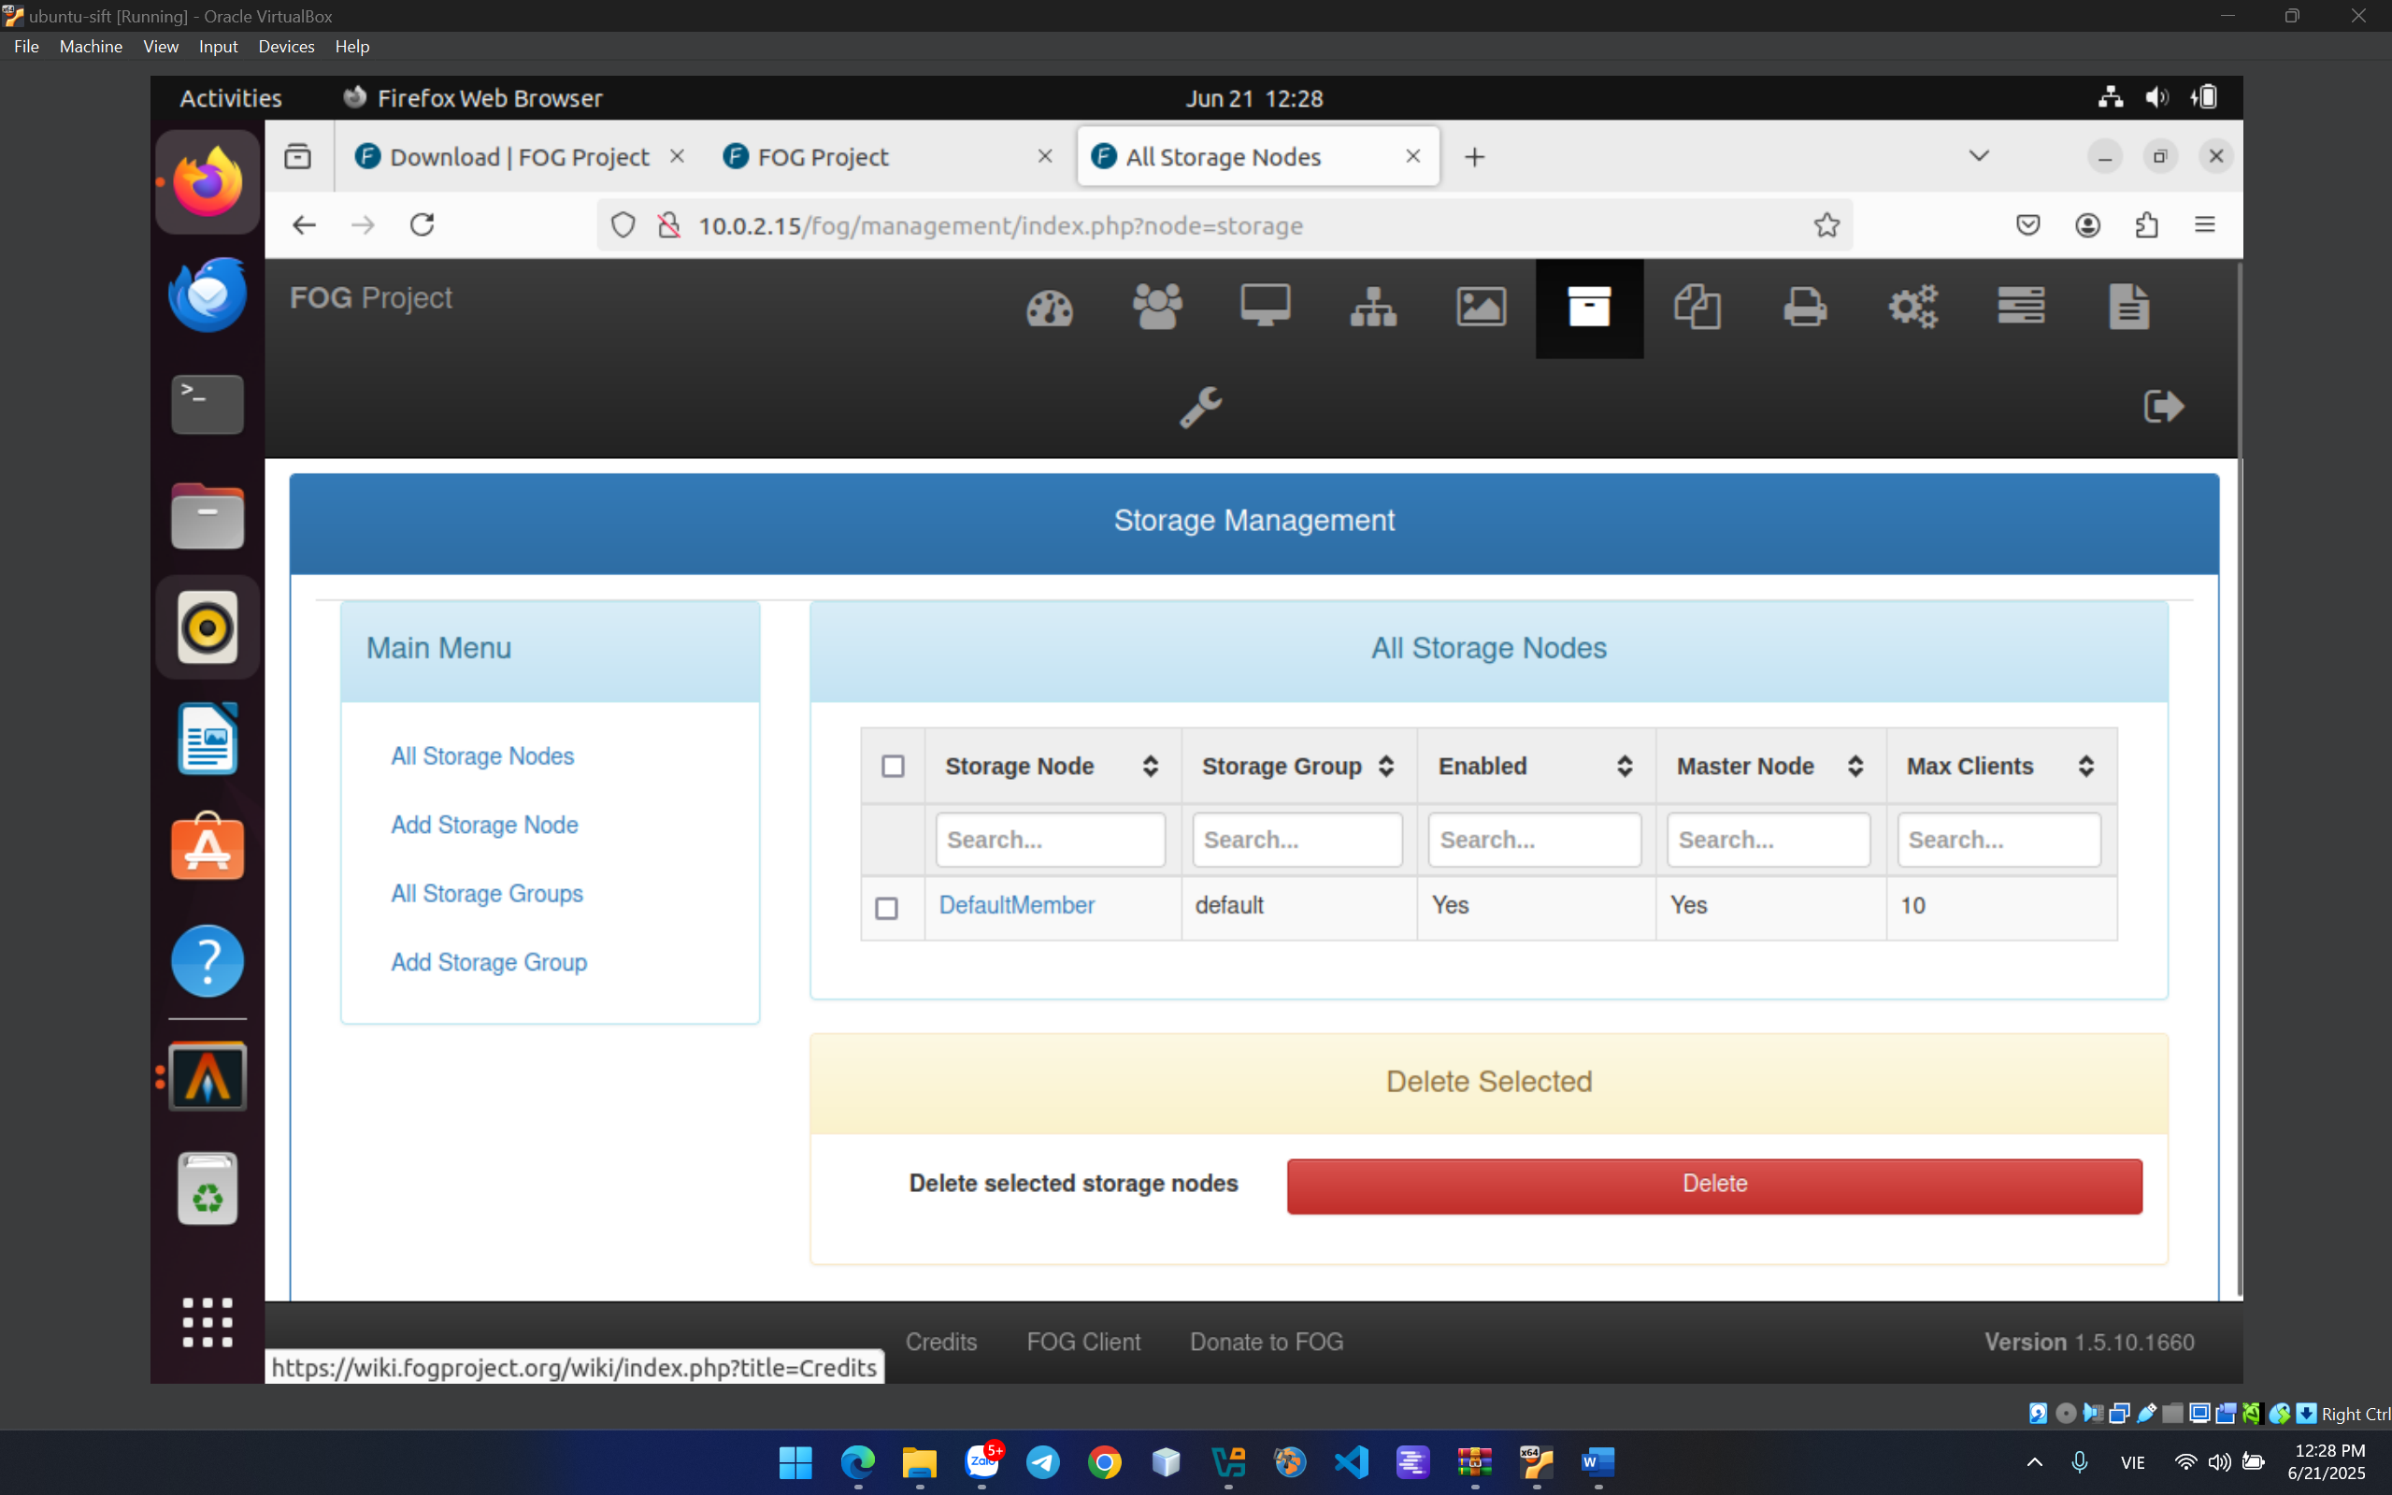

**CRACK ME 10**

This reverseme is written by Lena and is one of the classic reverseme’s used to learn reversing. Use this in conjunction with xAnalyzer plugin for x64dbg to practice serial key fishing.

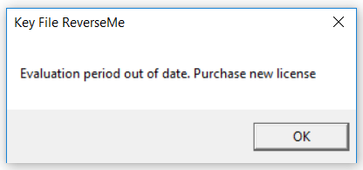

First, go to String references and see that, we have a keyfile.dat

So i create keyfile.dat on the same folder with file .exe

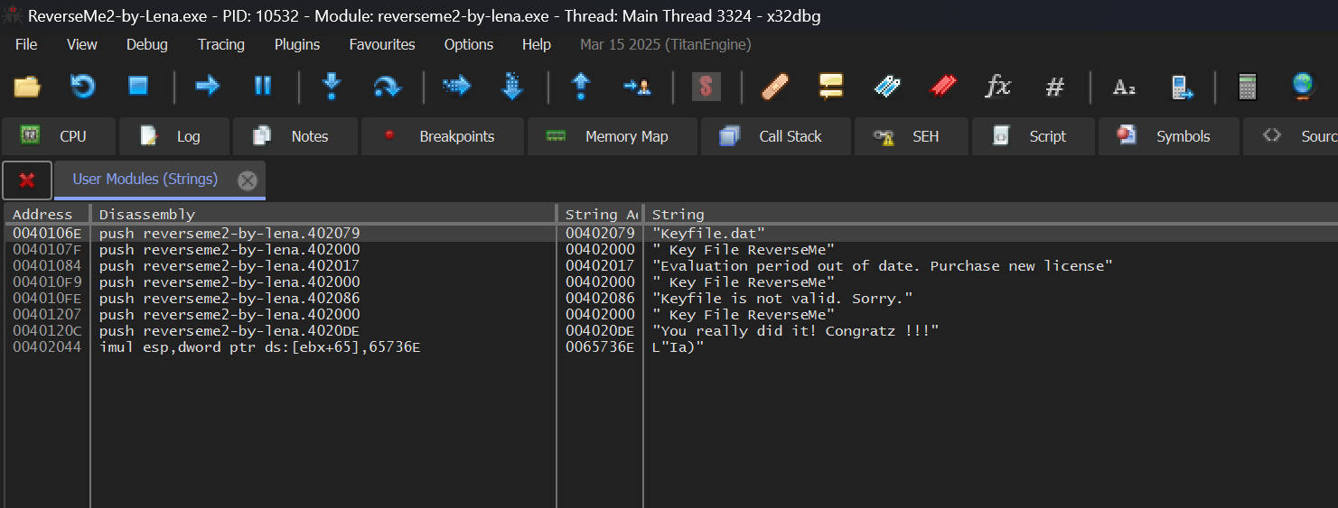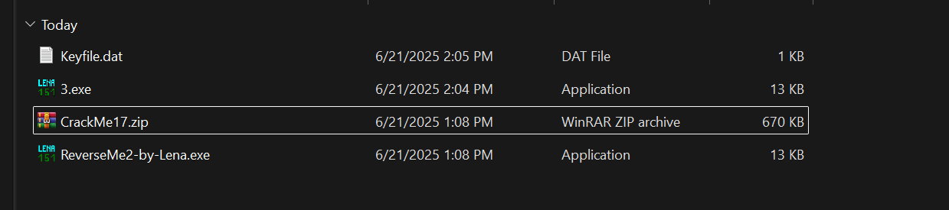

Next inspect to the assembly code of this string. 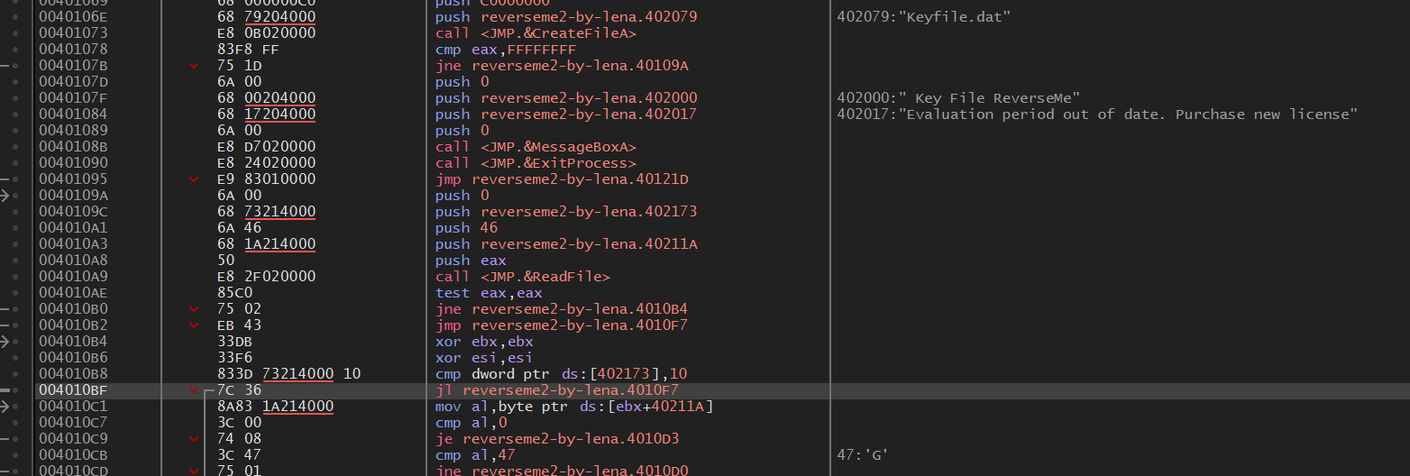

Notice the note “47:’G’”. May be this is the value of the string. So i type only one word G on keyfile.dat and receive this result. 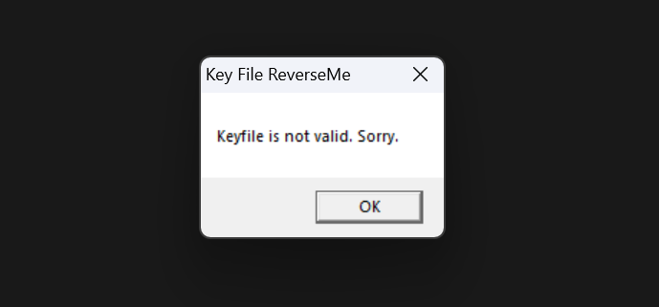

So i continue to analyze next code: 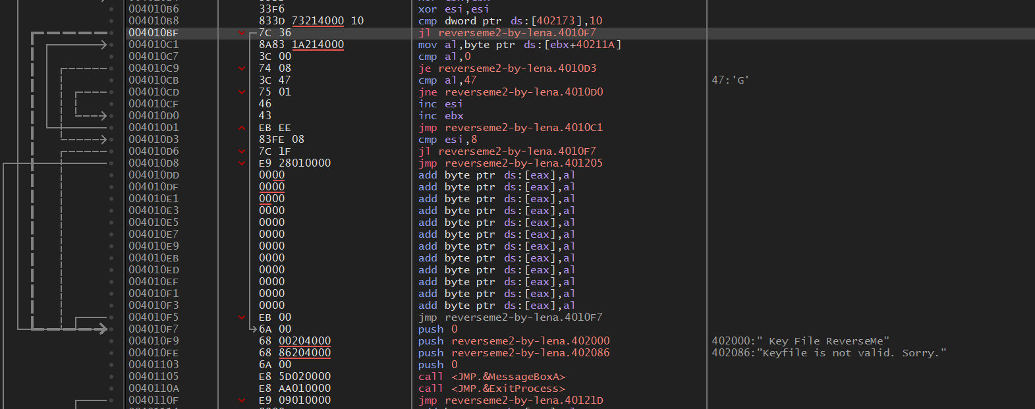

We have the CMP and JL.

Jump Low means if the ptr ds:[402173] lower than 10, program will jump to the status “Keyfile is not valid. Sorry.”

So i inspect to the DUMP of address 00402173 and see that these address contain value 0 so i change the CMP of this address with 0 to ignore JL command.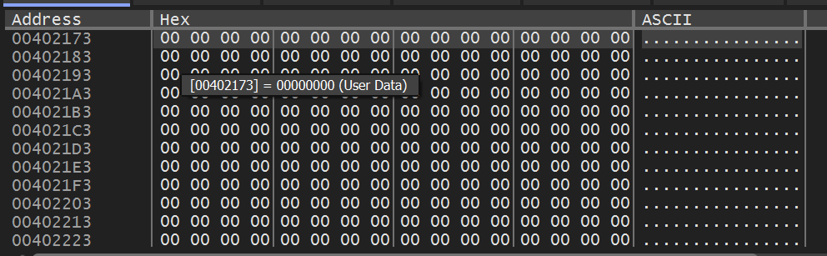

Next we need to find the content of keyfile.dat. We see that EBX and ESI represent for each byte of content and size of content respectively.

AL is assigned by EBX, and this compare with hexa 47 (letter G). ESI compares with 8 if lower we jump to status invalid. So the length of content is 8. We have the JMP of address 004010D1 creates the loop of comparing file content with G until AL equals to 0 (nothing to compare in EBX).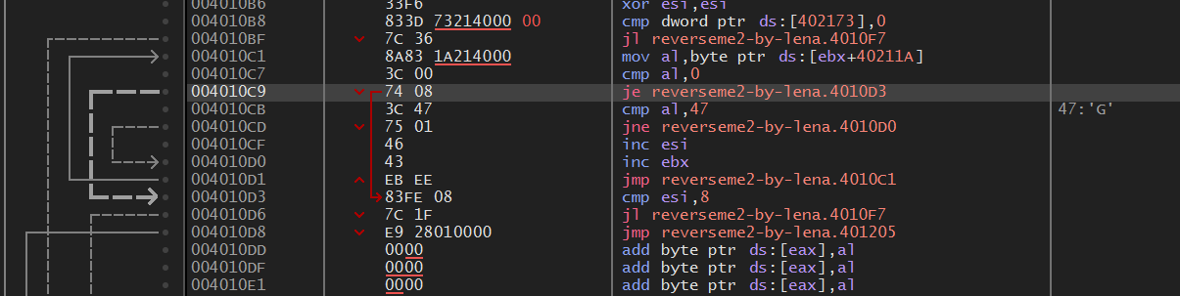

So we guest that the conten of Keyfile.dat is 8 letters G. So i type 8 times letter G in Keyfile.dat and patch file .exe to check. 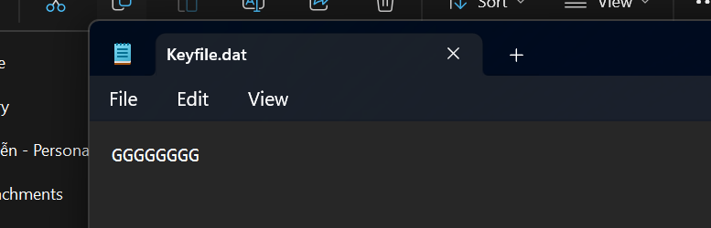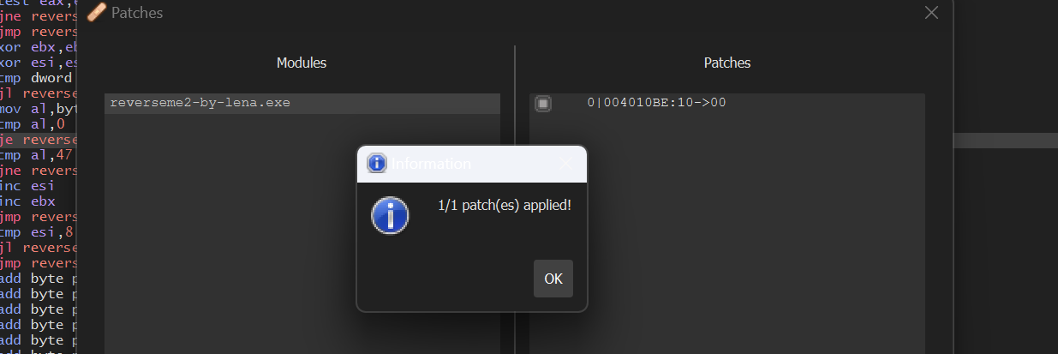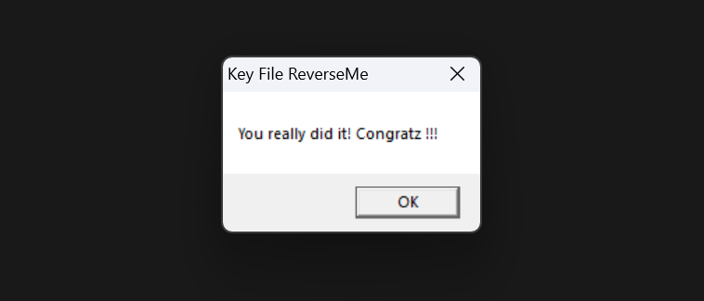

DONE!!!